CS/EE 120B

Custom Project: Remember the light

Kai Wen Tsai

Ktsai017

861261944

February 10, 2019

Introduction

Remember the light is a memorizing game that require to player to remember the sequence of LED that light up. The game will show up with a sequence of lights. Based on the level, the sequence gets complicated as the level goes up. Failing to input the correct sequence will restart the game. If the winner wins the final level, the winner text shows in the LCD screen.

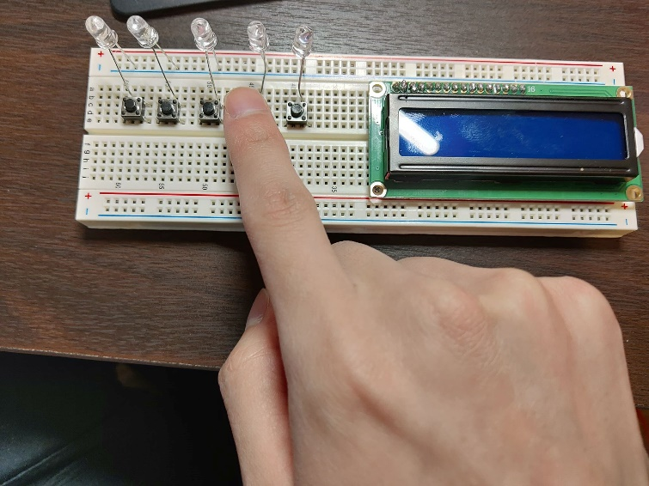

Components (Pin-out)

* **Inputs**
  + Many buttons
* **Outputs**
  + LCD screen that shows the level and winner text
  + LEDs to change the sequence based on level

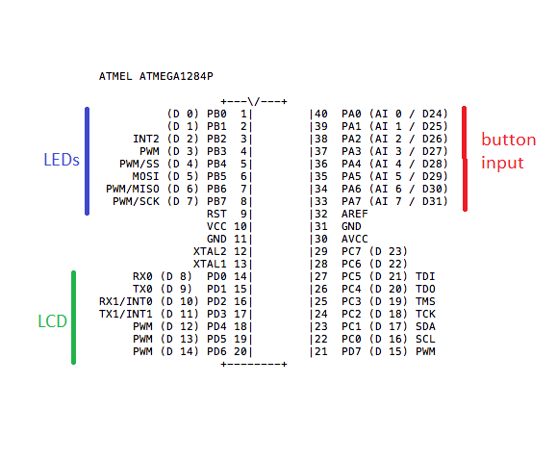

Complexities/Build-upons

1. Using the LCD screen to display the winner text and level
2. Flash LEDS in random sequence
3. Count if user input buttons sequence is correct
4. Using time for random function
5. Count the pulse of each input
6. Restart program if fail/ or win
7. Use buzzer speaker to play a melody when user wins